Documentation of US_county_Pop_density.dta
- Cases and variables
The data focus on population density of 3,142 counties from 2010 to 2018. There are 3,142×9= 28,278 county-year observations and 7 variables in data. A brief description of the variables is shown as below:
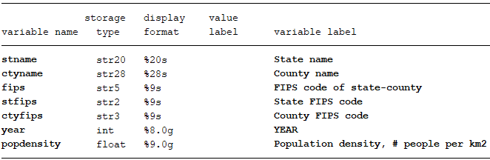

- Data source
The geographic area of each county is come from polygons calculation, and polygons of each county come from: https://gadm.org/

- Structure of raw tables
The result of county area calculation look like follow:
 | Country | state | County | area_sqkm
323869 | United States | Delaware | Kent | 1544.877663
323870 | United States | Delaware | New Castle | 1286.981103
323871 | United States | Delaware | Sussex | 2464.307075
323872 | United States | District of Columbia | District of Columbia | 166.0705505
323873 | United States | Florida | Alachua | 2506.692987
323874 | United States | Florida | Baker | 1527.13035
To get the population density in 2018, we need to match 1:m with US_county_Pop.dta to get total population. Note, we treat area as an constant value for each county.

